**AMERICAN INTERNATIONAL UNIVERSITY–BANGLADESH (AIUB)**

**FACULTY OF SCIENCE & TECHNOLOGY**

**DIGITAL LOGIC AND CIRCUITS LAB**

**Summer 2022-2023**

Section: F

Group Number: 02

**EXPERIMENT NO. 6**

**NAME OF THE EXPERIMENT**

*Study of Different Flip-Flops*

**Supervised By**

SHAHRIYAR MASUD RIZVI

Faculty of Engineering, AIUB

**Submitted By**:

|  |  |
| --- | --- |
| **Name of the Student** | **ID Number** |
| 1. NOKIBUL ARFIN SIAM | 21-44793-1 |
| 1. AHNAF AHMED | 20-42173-1 |
| 1. SAIFUL ISLAM | 20-42585-1 |
| 1. MAHADI HASAN | 19-39711-1 |
| 1. SHEIKH FAHIM FUAD | 21-44721-1 |

**Introduction:**

The basic building blocks of combinational logic circuits are gates. In particular, AND, OR,

and NOT gates (however, there are also XOR, NAND, NOR, and XNOR gates).

The basic building blocks of sequential logic circuits are flip flops. Flip-flops are devices that

use a clock. Each flip-flop can store one bit. There are different types of flip-flops. D flip-flop,

T flip-flop, J-K flip-flop, etc.

**Theory and Methodology:**

A flip-flop has two/three inputs. One input is a control input. For a D flip flop, the control input is labeled D. For a T flip-flop; the control input is labeled T. For the J-K flip-flop, the control inputs are J and K. The other input is the clock.

The clock input is usually drawn with a triangular input. These flip-flops are *positive edge-triggered flip-flops*. This means the flip-flops can only change output values when theclock is at a positive edge. There are also negative edge-triggered flip flops, which vary ona negative edge. In this theory section, we consider only positive edge-triggered flip flops.

When the clock is not at a positive edge, then the output value is held. That is, it does notchange.

A flip flop also has two outputs, **Q** and **Q'**. The output is really the bit that's stored. Thus, the flip-flop is always outputting one bit of information.

But one might wonder "Doesn't it have two bits of information? **Q** and **Q'**?” If we have two bits, we have four possible values. However, **Q'** is the negation of **Q** which means you only have two possible outputs: **Q = 0, Q' = 1** or **Q = 1, Q' = 0**. Since the second output is always negated from the first, you don't get any additional storage. But what is the necessity of the negated output? Actually, the design of flip-flop gives **Q'** basically for free, so that's why flip-flops have both the regular output and the negated output.

**D Flip-Flop:**

In a positive edge triggered D flip-flop, the output **Q** samples the input **D** and becomes **Q = D** only at the positive edge of the clock and it does not change during the whole clock cycleeven if the input changes.

Sometimes flip flops often have two additional inputs called *clear* and *preset*. Conventionally they are drawn at the top and bottom of the flip flop respectively. ‘Preset’ and ‘Clear’ can be either active low or active high. If the preset is active, the output will be 1 no matter what are the conditions of D or clock. But ‘clear’ has two types. Asynchronous clear and synchronous clear. If the asynchronous clear is activated, it causes **Q** to be automatically set to 0. It does this, even if the clock has not reached a positive edge. That is, it sets Q to zero as fast as it can. The asynchronous clear is often used to reset flip flops to some initial value. But for synchronous clear, **Q** will be 0 if the clear is active when the clock is in a positive edge.

There are different ways to design a D flip-flop. In this lab sheet, only one way is shown. Students will be familiar about other ways in their theory class.

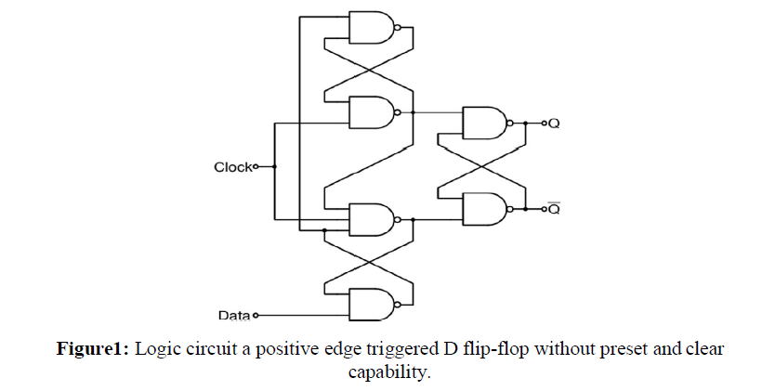

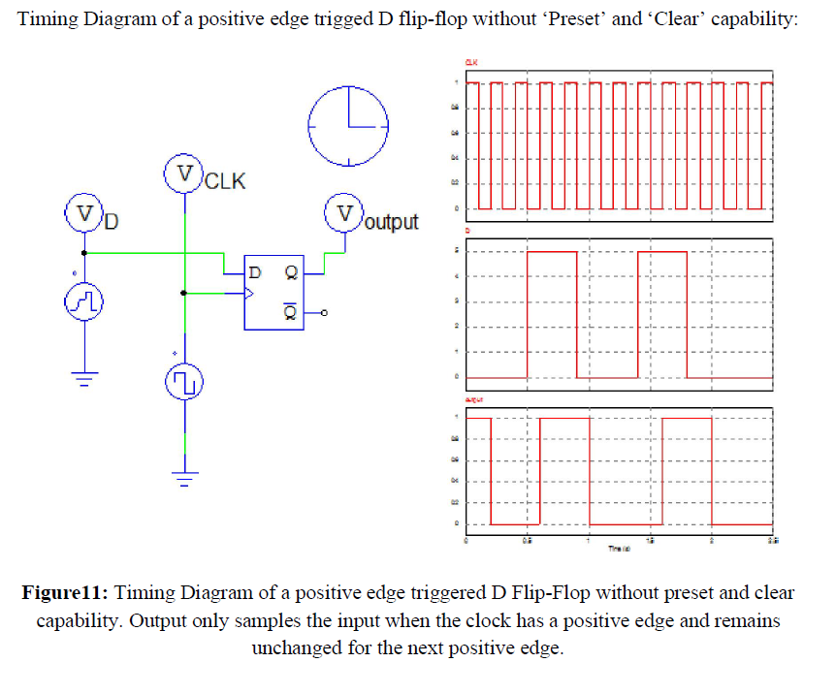

**J-K Flip Flop:**

In a J-K flip-flop, there are two control input labeled as J and K and a clock input. It has two outputs Q and Q’ as usual. In a positive edge triggered J-K flip-flop, output only changes at the positive edge of the clock depending on the values of J and K. If J=1 and K=0, Q is set to 1. If J = 0, K=1 then Q is set to 0. If J = 0 and K = 0 then Q remains unchanged. If J = 1 and K = 1 then Q changes from its former value, which we can say the output toggles.

We can show the characteristics of a J-K in a table given below.

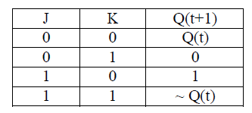

J-K flip-flop can be designed easily using D flip-flops.

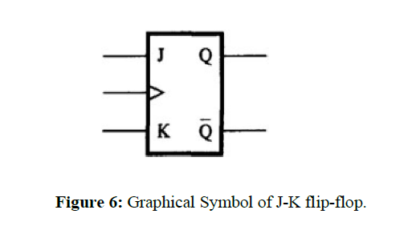

**T Flip-Flop:**

A T flip-flop has a control input labeled as T and a clock. The characteristic of a T flip-flop is such that the output toggles at the positive edge of the clock if T is 1. But if T is 0, the output remains unchanged even at the positive edge of the clock.

A T flip-flop can be designed easily by making J and K short of a J-K flip flop.

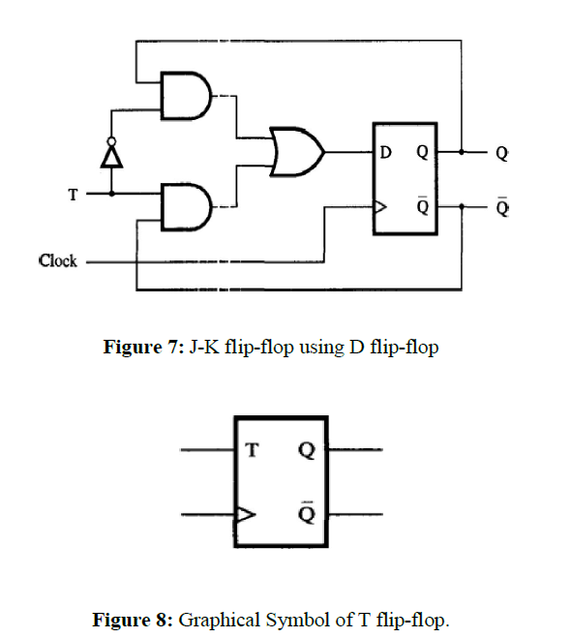

There are built-in ICs for D flip-flop and J-K flip-flop. IC-7474 contains 2 D flip-flops and IC-7476 contains 2 J-K flip-flops. The pin configuration of IC-7474 and IC 7476 are given below.

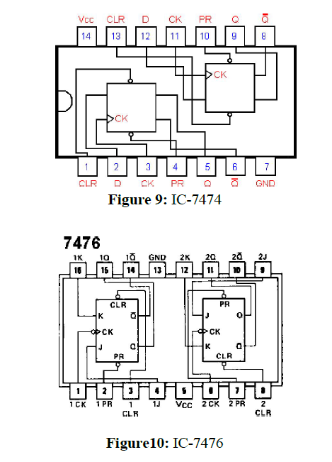

**Apparatus:**

IC: 7404 (NOT Gate) 1[pcs]

7408 (AND Gate), 2[pcs]

7432 (OR Gate) 1[pcs]

7400 (NAND Gate) 6[pcs]

7474 (D flip-flop) 1[pcs]

7476 (J-K flip-flop) 1[pcs]

**Hardware Implementation:**

**D flip-flop**

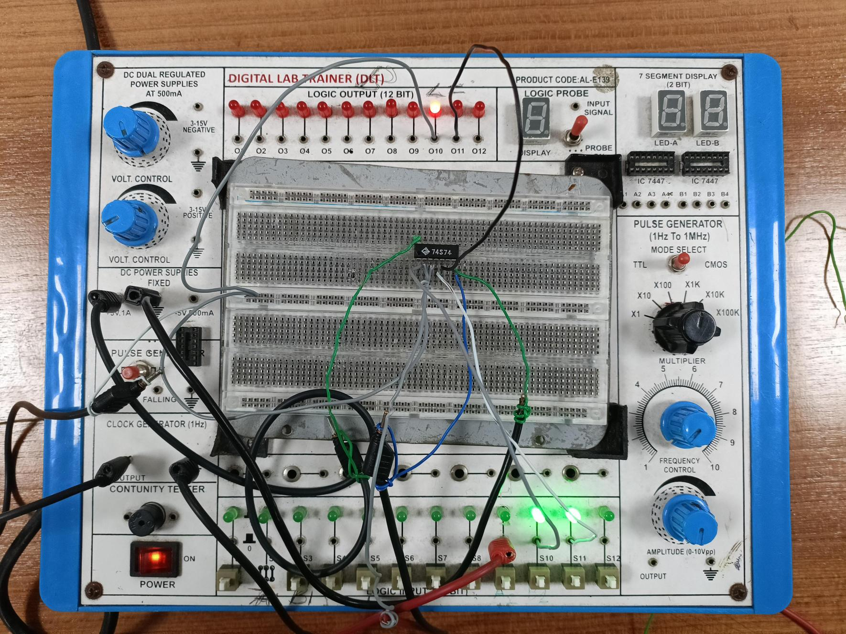

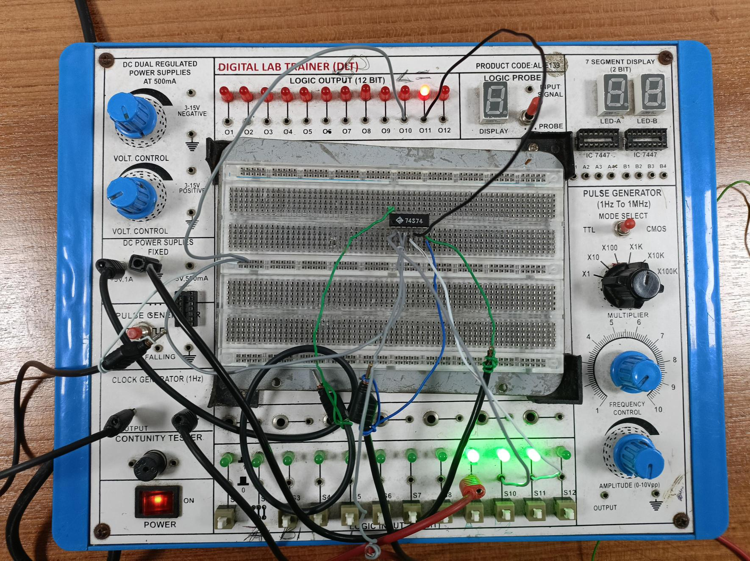

**J-k flip-flop**

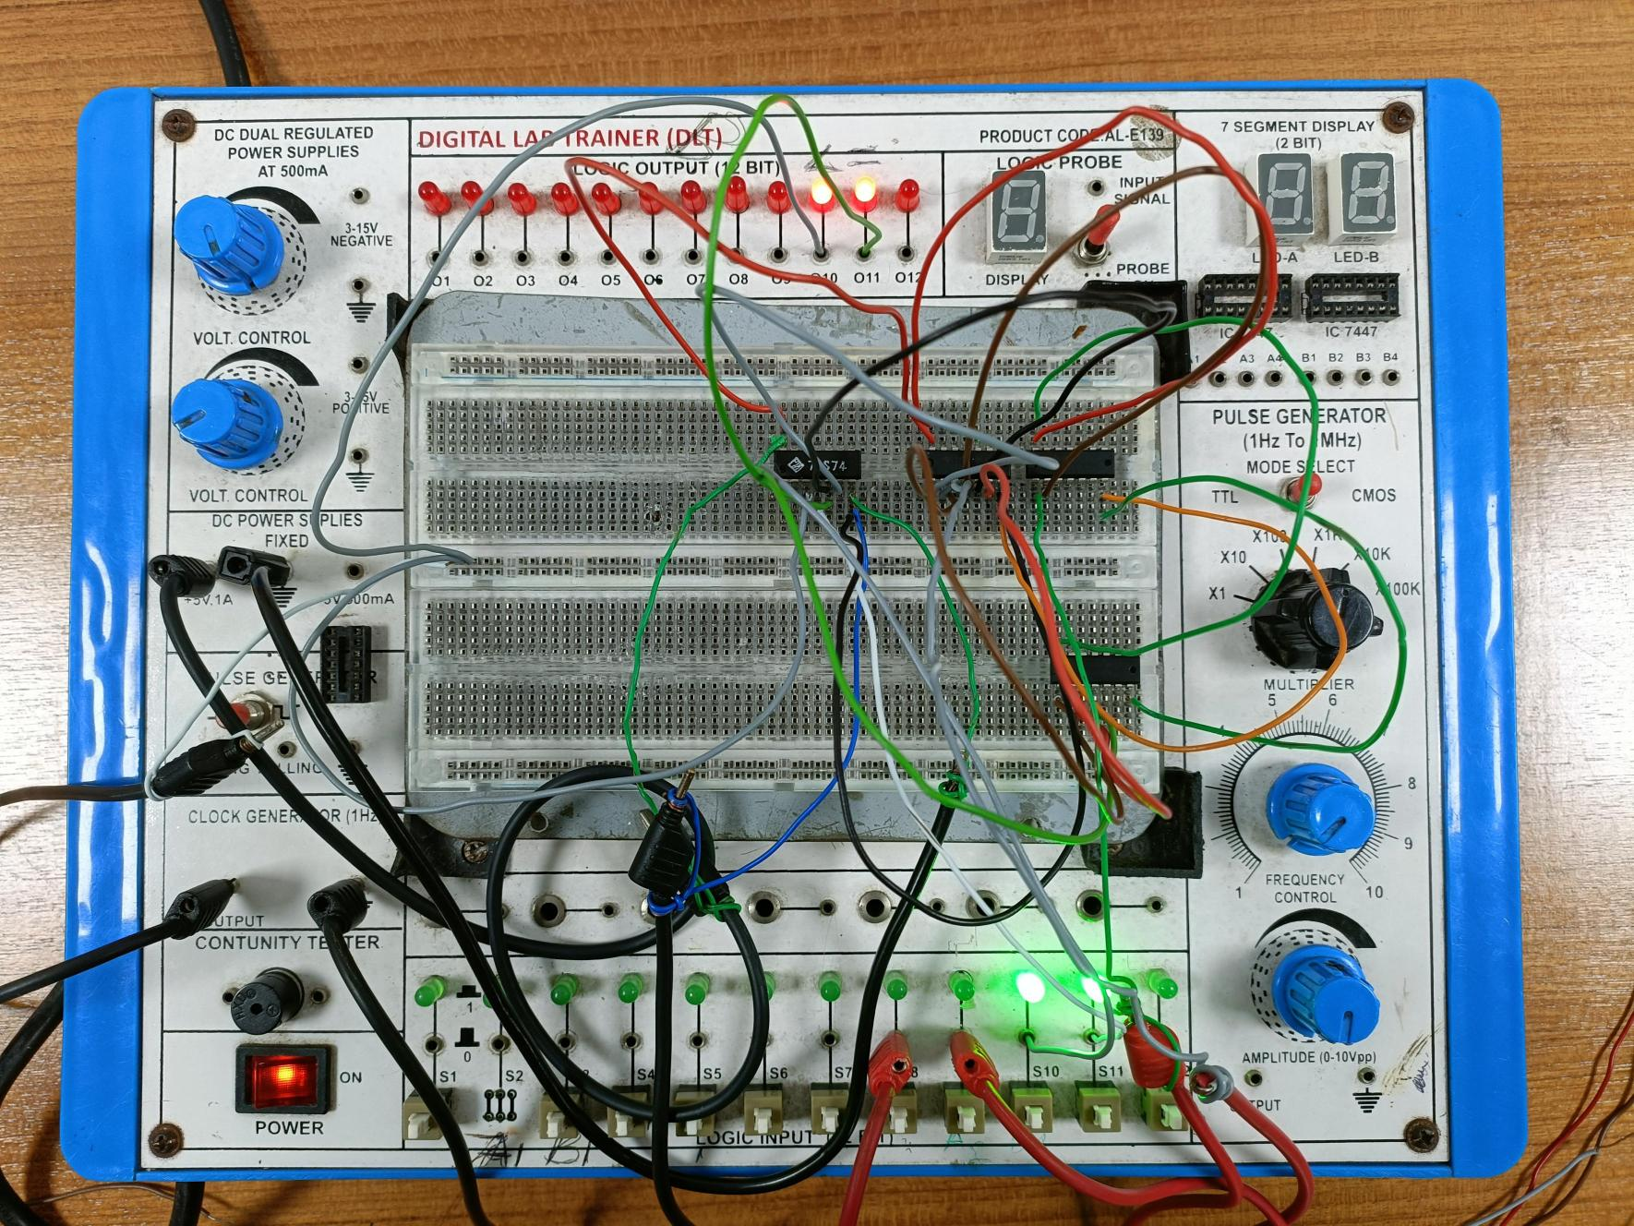

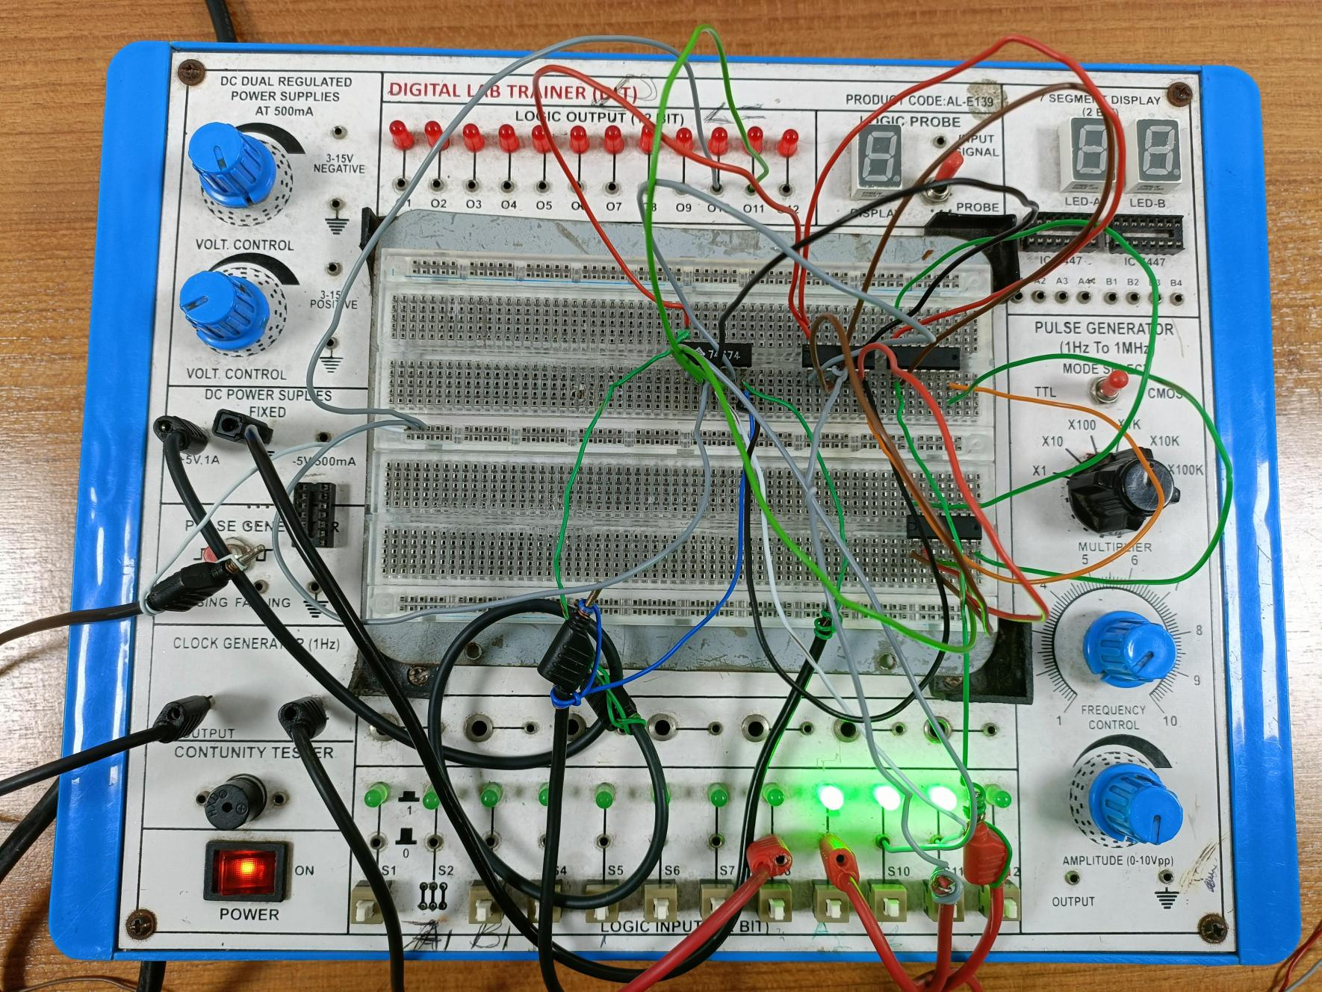

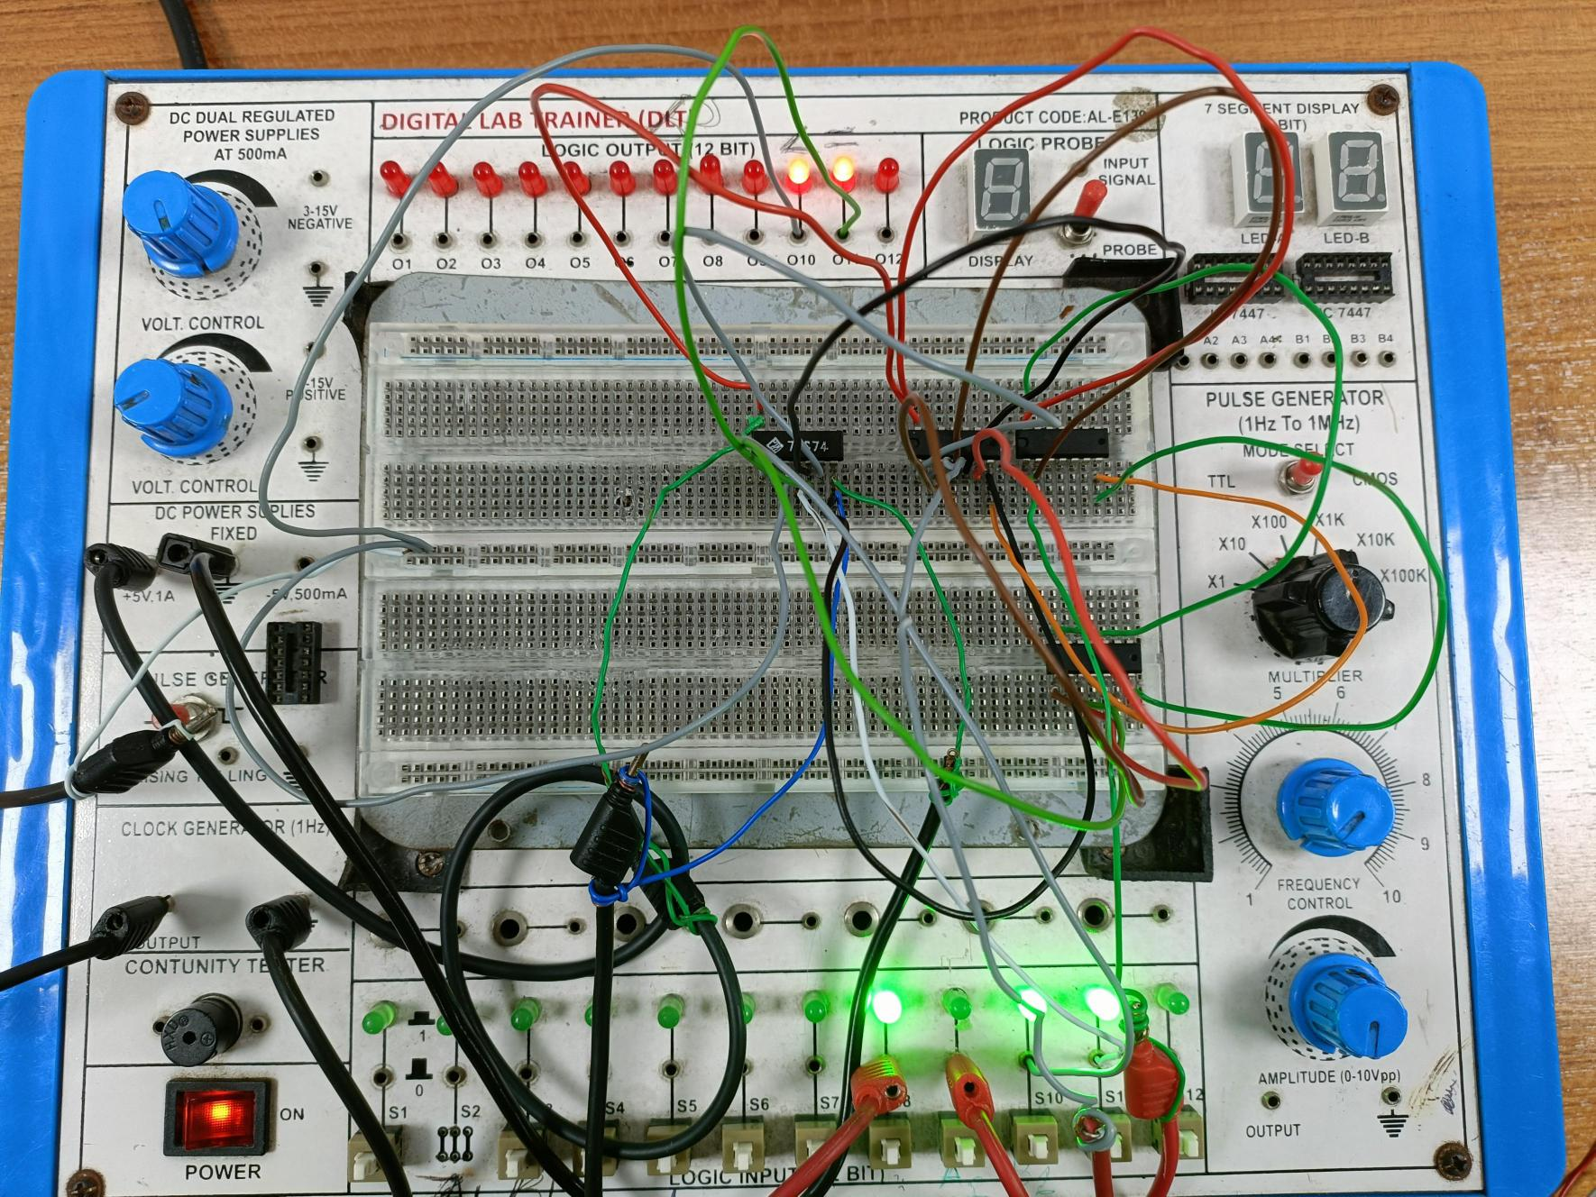

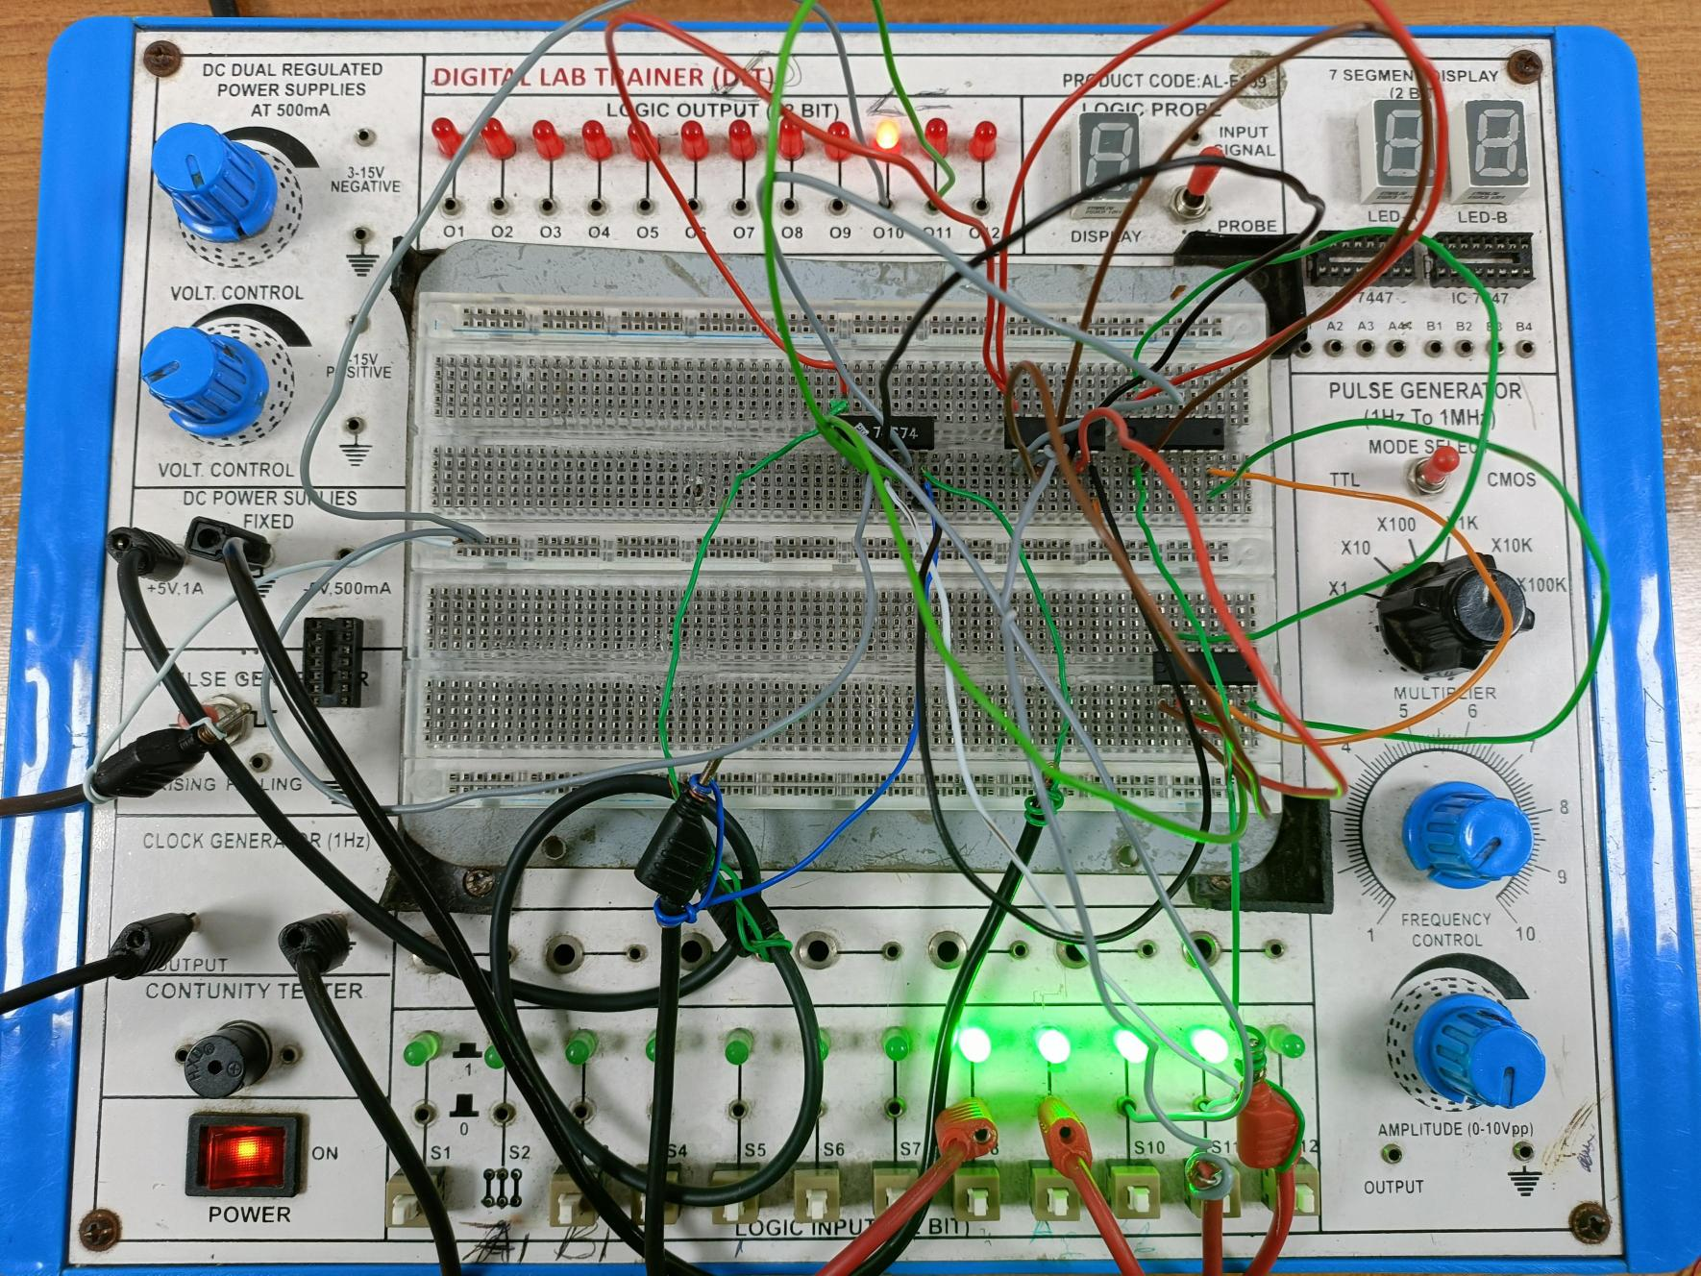

**T flip-flop**

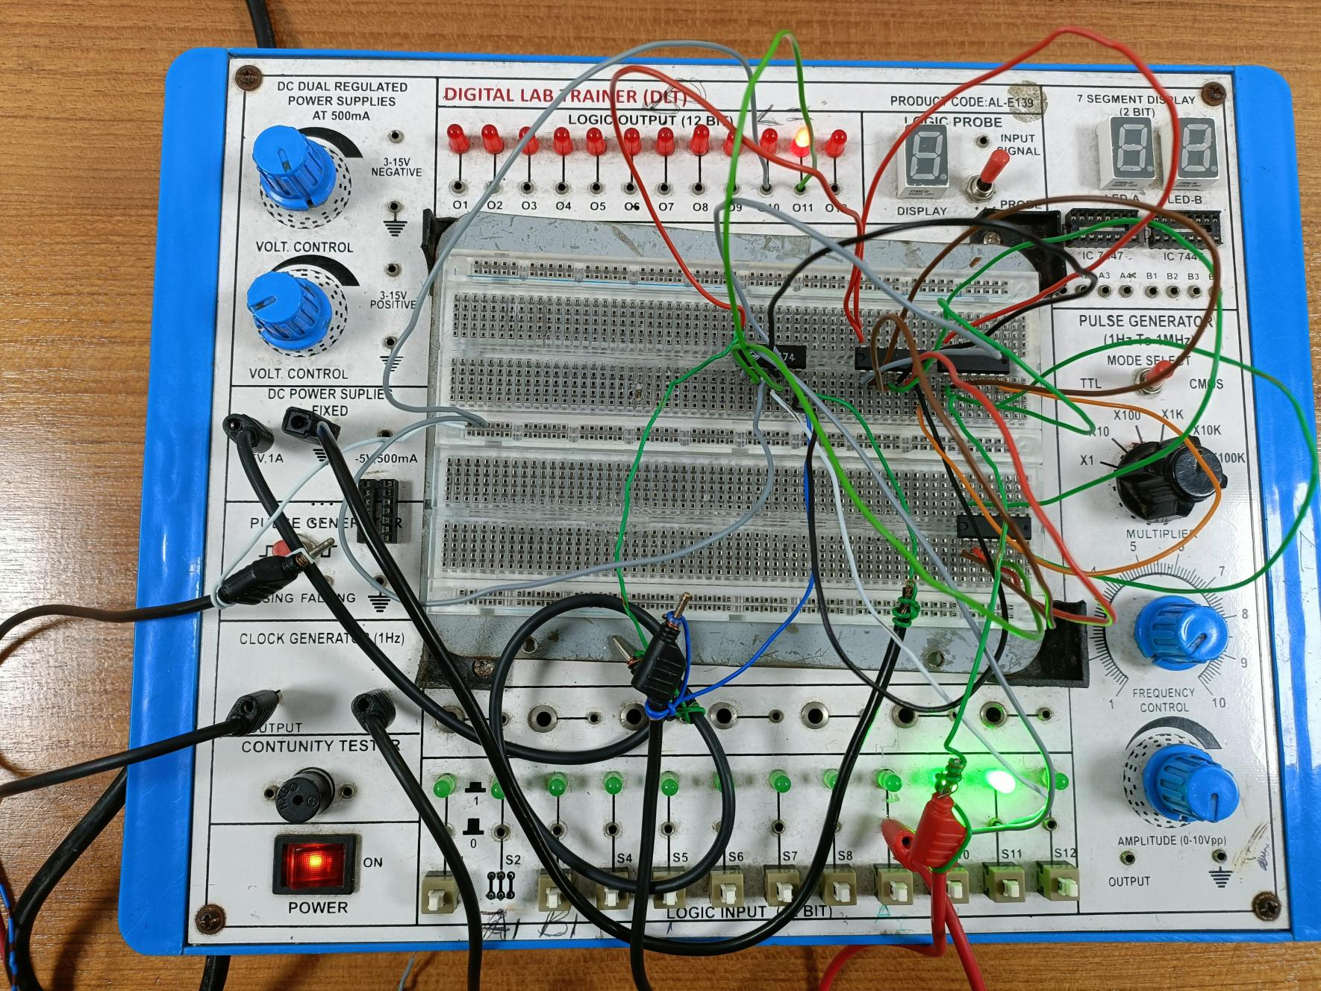

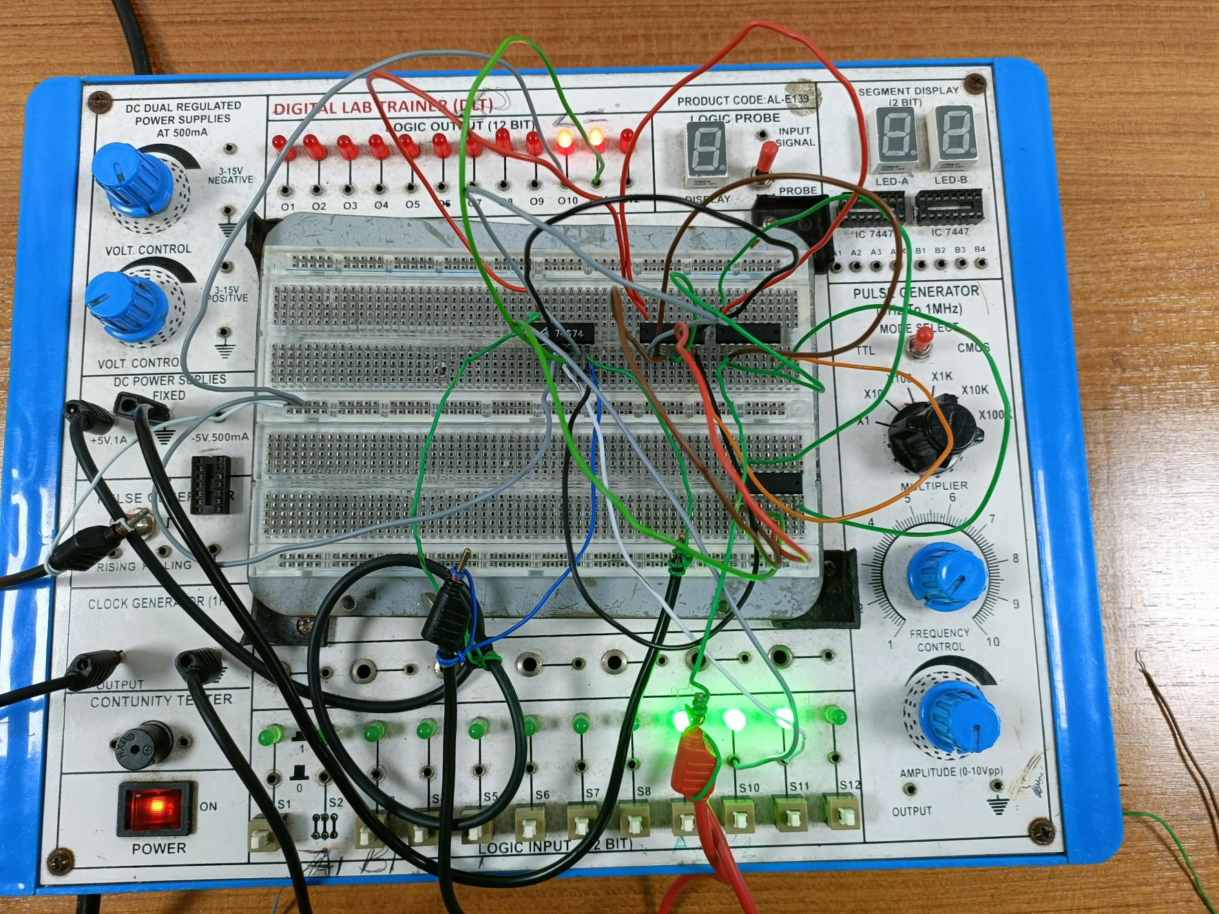

D Flip-Flop from NAND:

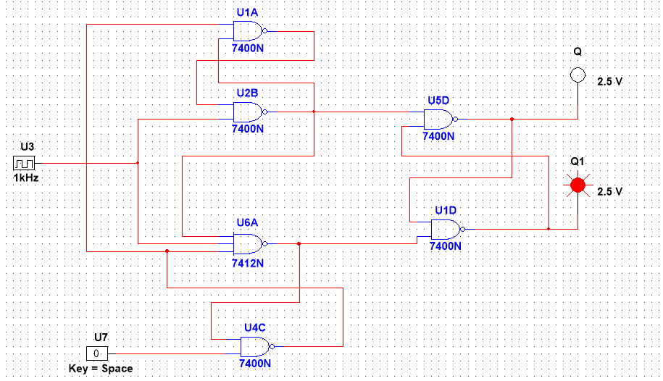

Fig: input – 0; output (Q) – 0

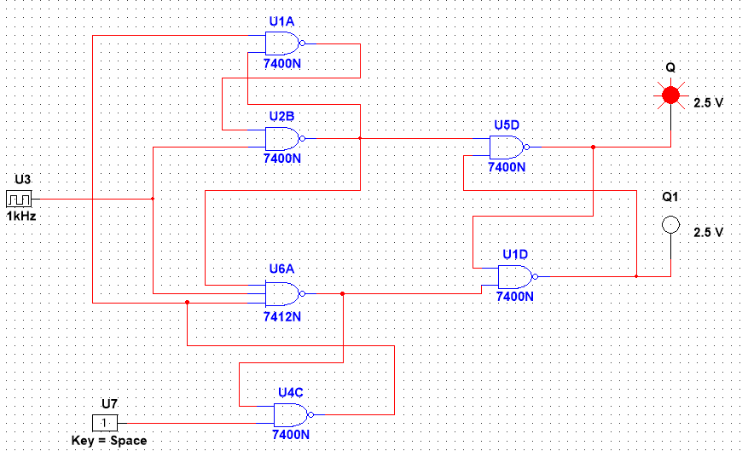

Fig: input – 1; output (Q) – 1

**J-K flip-flop**

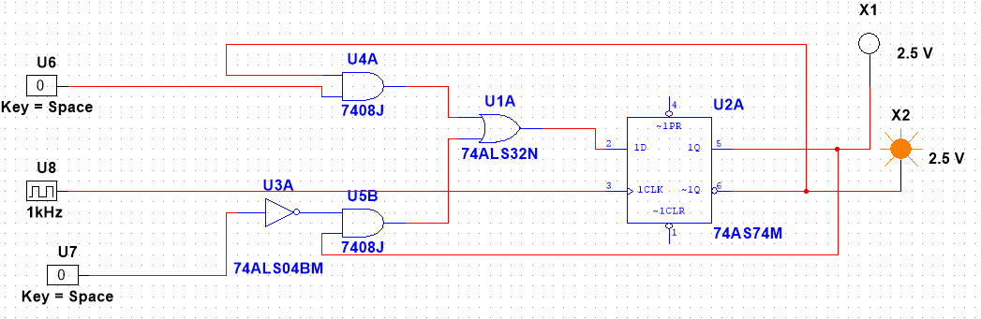

Fig: input – 0 0; output (Q) – 0 (No change)

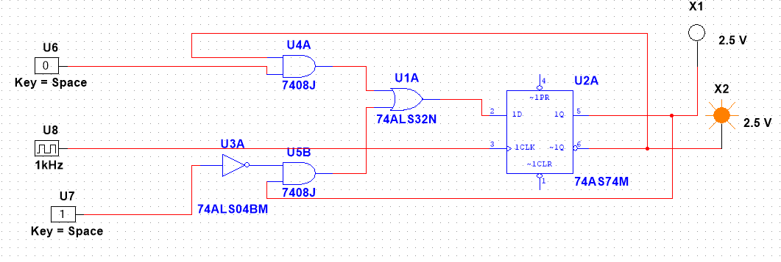

Fig: input – 0 1; output (Q) – 0 (Reset)

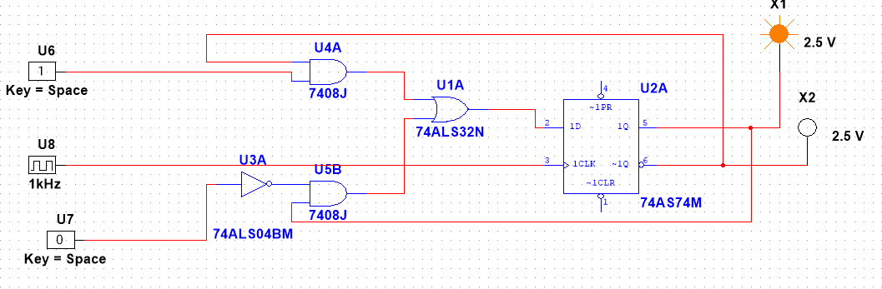

Fig: input – 1 0; output (Q) – 1 (Set)



Fig: input – 1 1; output (Q) – 0 (Toggle)

**T flip-flop**

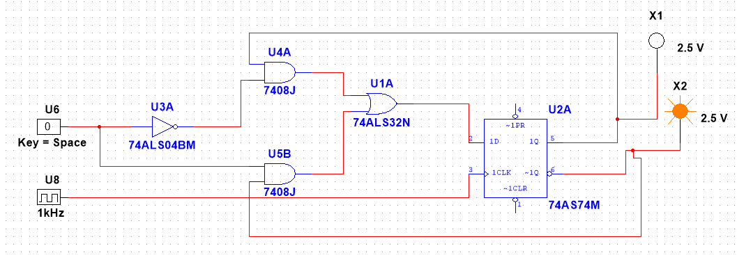

Fig: input – 0 ; output (Q) – 0



Fig: input – 1 ; output (Q) – 0 (Toggle)

**D Flip-Flop**

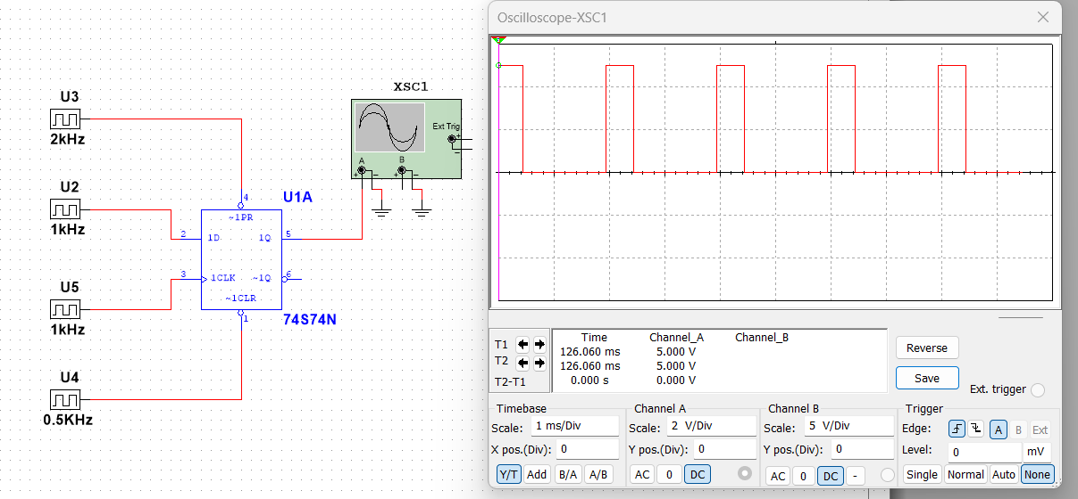

**Results:** The Simulation results matched the hardware implementation.

**Discussion:**

After performing this experiment, we became familiar with the design of positive edge triggered D flip-flop with and without ‘Preset’ and ‘Clear’ capabilities, J-K flip-flop, and T-flip-flop. After the experiment, our job was to design negative edge-triggered flip-flops and draw the timing diagrams for them. We have also designed and drawn a timing diagram for a D flip-flop having active high ‘Preset’ and ‘Clear’ pins.

**Reference:**

1. “Fundamentals of Digital Logic with verilog design” by – Brown &Vranesic

2. www.wikipedia.org

3. http://www.cs.umd.edu/class/spring2003/cmsc311/Notes/Seq/flip.html